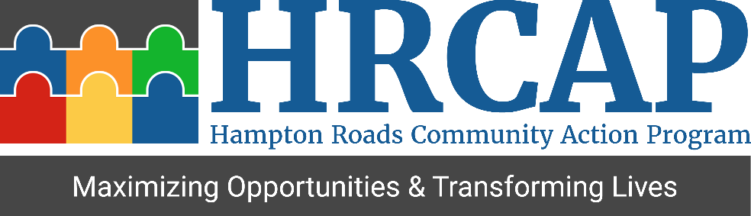
Youth Participant Registration

To begin, please verify the following requirements.
Are you a resident of Newport News?
☐Yes
☐ No

Personal Information
First name
Middle name
Last name
Suffix
Date of birth
Gender
☐Male
☐Female

Contact Information
Street address
Apartment /Unit (optional)
City
State
Zip code
Primary phone number
Alternate phone number (Optional)

Education
What is the highest level of education you have completed?
Are you currently enrolled in college/university? If so enter the name.
College major (optional)
Would you like to receive information for a GED program?
☐Yes ☐No

Employment
If yes, please select all the years you participated.
☐2014 ☐2015
☐2016 ☐2017

If you have previously participated in STEP, why do you want to participate again?
Do you have any prior work experience?
☐Yes ☐No
Prior job names or positions held
Prior job duties
Do you have a resume?
☐Yes ☐No
Below is a sample of positions available. Please select at least three that interest you.
☐ Office; paperwork, organizing, answering phones
☐ Hospitality and tourism; welcoming and guiding visitors
☐ General cleaning and maintenance (inside)
☐ Working with children (requires background check)
☐ School cleanup; setup for next school year
☐ Artistic Design &Creation
☐ Medical
☐ Funeral Service
☐ Restaurant /Food Service
☐ Culinary Program (must be at least 18 years of age)
☐ Landscape/ Lawn Care
☐ Manufacturing
☐ Animal Care/Engagement
☐ Other
☐ Any of the above

Additional Information
What is your t-shirt size?
Have you ever been convicted of a crime or have any pending charges? Please note if selecting yes, you will not automatically be disqualified for the program.
☐Yes ☐No
How do you plan to attend mandatory program events and the daily work site?
Do you have a personal bank account in your name?
☐Yes ☐No
Banking institution name (optional)
How did you hear about STEP?
☐School
☐Friend
☐News
☐Social Services
☐Facebook
☐ City of Newport News
Other (please enter in the box below)
Do you have any concerns being involved in STEP?
Why do you want to participate in this program?
Describe your future career, education, or other personal goals.
Describe the biggest challenge you may face trying to achieve your goals.
What are your plans after summer?
Certification
Applicants under 18 will need approval from a parent /guardian in order to participate in STEP. The parent/ guardian will also be required to attend a mandatory program registration session. If I am under 18, my parent/ guardian granted me permission to participate in this program?
☐Yes
☐Not Applicable
Parent Name
Parent Phone Number

By submitting this form, I certify that all information and statements I have provided in this registration are current, correct, and complete to the best of my knowledge.

